MICHAEL ORINA
SCII/00825/2019

UNIX AND WINDOWS SERVER OS ASSIGNMENT 1

1. State 2 broad categories of Software (2 Marks)

- System Software.
- Application Software.

2. State 4 Examples of Operating Systems (2 Marks)

- Parrot OS
- Kali Linux
- Ubuntu OS
- Windows OS

3. State the main functions of Operating Systems (2 Marks)

- Manage the computer's resources, such as the central processing unit, memory, disk drives, and printers.
- Execute and provide services for applications software.
- Establish a user interface.

4. Using a Diagram describe the Unix Architecture (5 Marks)
Unix has a graphical user interface similar to the Windows operating system that makes it easy for navigation and a good supportive environment.

The internal design view of this operating system can be known from its architecture.
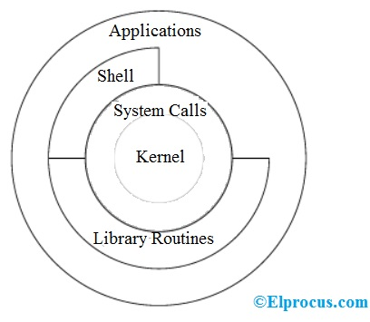

The architecture of this operating system is four layered. It consists of Hardware, Kernel, System Call interface(shell) and application libraries/tools, utilities, etc…
The kernel controls the hardware of the computer and resides at the core of the architecture.

System calls acts as the interface between the kernel and other libraries.

These libraries include general functions and built on top of the system calls.

Shell is a special application that provides an interface to the other applications of the architecture.

5. List 4 Variations of the Unix Operating System (2 Marks)

- Solaris
- SunOS
- AIX
- ULTRIX

6. Compare and Contrast Between a client operating system and server operating system. (4 Marks)

1. Client OS :
It is an operating system that operates within desktop. It is used to obtain services from a server. It run on the client devices like laptop, computer and is very simple operating system.
2. Server OS :
It is an operating system that is designed to be used on server. It is used to provide services to multiple client. It can serve multiple client at a time and is very advanced operating system.

Server Operating System | Client Operating System
It can be used to provide services to multiple client. | It can obtain services from a server.
It can serve multiple client at a time. | It serves a single user at a time.
It is complex operating system. | It is simple operating system.
It runs on the server. | It runs on the client devices like laptop, computer etc.
It is an operating system that is designed to be used on server. | It is an operating system that operates within desktop.
It provides more security. | It provides less security.
It has greater processing power. | It has less processing power.

